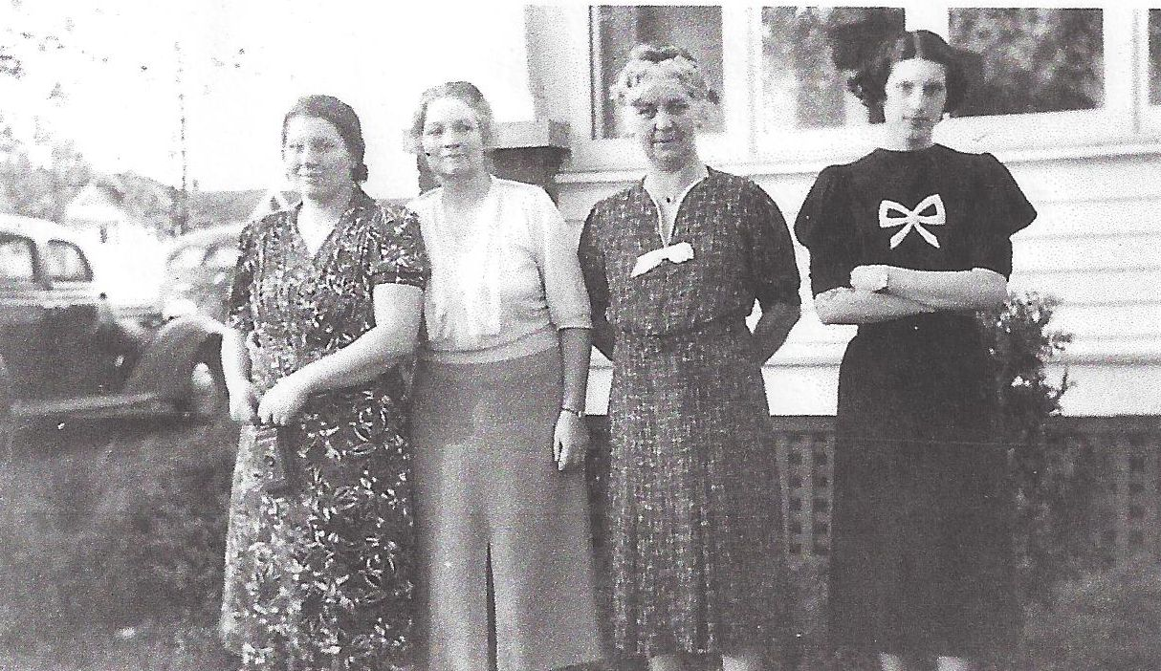

**Dorothy E. Wolfe List, Josephine S. Worthen Wolfe,**

**Anna Worthen, Cecile Worthen – about 1939**

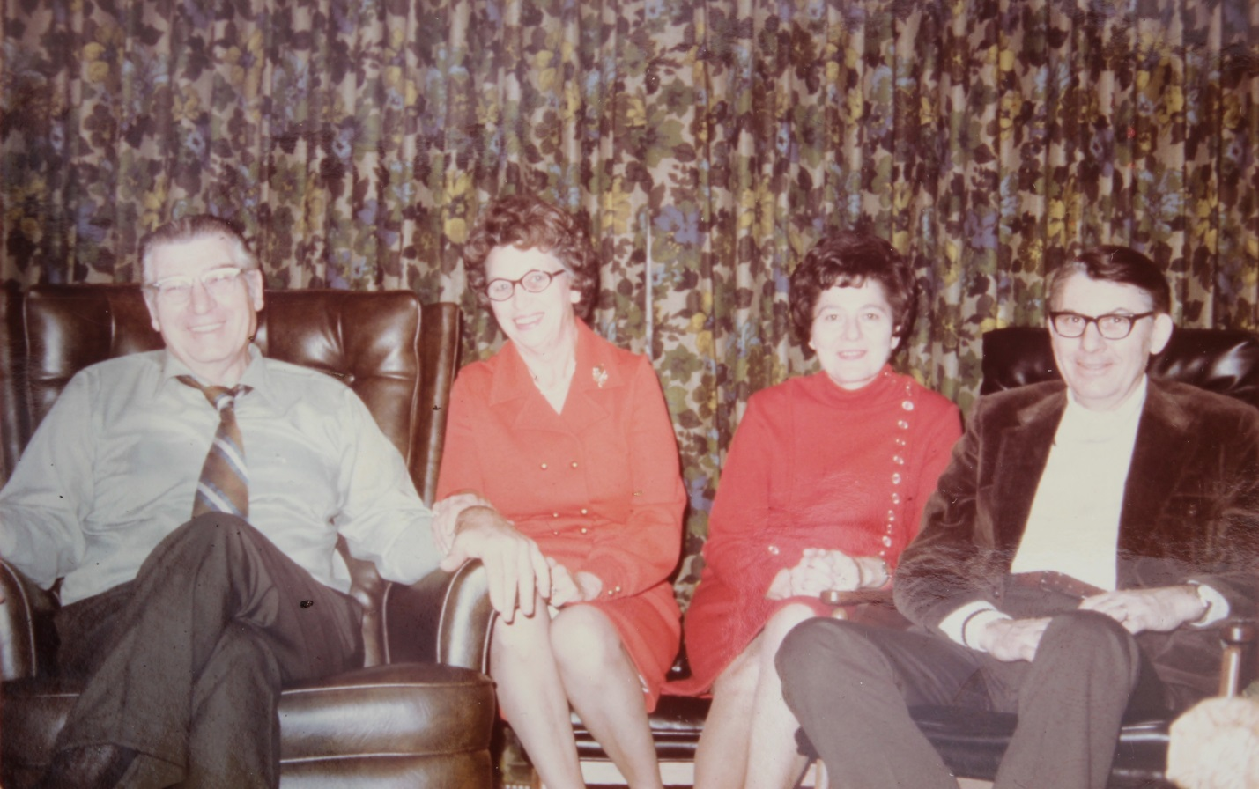

Russell Wolfe, Mary Foster Wolfe, Jessie Dresbach Wolfe, Roger Wolfe – about 1971

**Foster and Related Family Lines**